Introduction

|  |  |
| --- | --- |
| Idea: | Create a simple but needed website, that lets people know how serious their condition is, while also calming the more paranoid down.  A menu will take you through your symptoms and at the end, you will be presented with a couple top doctors from your region and their opinions. |

|  |  |
| --- | --- |
| Start: | First we will finish the concept and plan every detail carefully.  Then we will hit the streets and ask people what they think about our idea. If they like it, ask them for a signature for our petition. This petition we will use to convince doctors that our website is profitable for us, them and the people all over.  We will then create a form and a points system for the doctors to complete. The point system will allow us to create an algorithm that will help select the best possible “doctors answer” from the database and display to the user, based on their symptoms. |

|  |  |
| --- | --- |
| What the website will not do: | 1. Tell you what disease you have. 2. Tell you about diseases. 3. Go into detail about your symptoms. 4. Be a substitute for a real doctor. |

Implementation

|  |  |
| --- | --- |
| Implementation of search: | When you first open the page up, your will be taken through a profiling method.   1. You must enter your Age, Weight, Gender, Region and Allergies/Known Illnesses. 2. You must choose the part of the body that hurts or discomforts you (e.g. Upper-Body, Lower-Body etc.). 3. You must choose what organ or specific part of body hurts (e.g. Heart, Lungs etc.). 4. You must choose whether you are in pain or discomfort and for how long you have had these symptoms. 5. A result of the three top doctors in your area will give you their short opinion on the matter. |

|  |  |
| --- | --- |
| Implementation of results: | 1. Portraits    * Will be displayed at the top.    * Will be three of them.    * Age and Region will be displayed underneath.    * Clicking on the portrait will bring up a small Pop-Up with more information about the doctor (Name, Age, Address, Personal Text). 2. Dr. Opinion    * One or two short sentences.    * Whether the user should go see a doctor or not.    * If the user should do a blood test or not. 3. Symptoms    * Will be displayed at the bottom.    * Short list of what the user chose in the profiling part. |

|  |  |
| --- | --- |
| Technologies used: | 1. HMTL/CSS    * Creating and designing the website. 2. JavaScript    * Animation/forms.    * Responsive 3. MySQL    * Create the database that will store the answers. 4. PHP    * Connect the website to the database. |

|  |  |
| --- | --- |
| **Monetization** | |
| Sponsorship: | Doctors that will want to be in the top 3 choices for their city, must pay a monthly fee. This will promote their practice and help the website grow. |
| Affiliate Links: | An affiliate link is a specific URL that contains the affiliate's ID or username. In affiliate programs, advertisers use affiliate links to record the traffic that is sent to the advertiser's website. This action is all part of an affiliate program. |
| Shop: | A shop containing fun and practical doctors and health themed figurines, T-Shirt and more. |

|  |  |  |
| --- | --- | --- |
| **Search Menu** | | |
| Head |  |  |
|  | Pain | Headache, Stabbing pain |
|  | Discomfort | Fever, Dizziness, Hallucinations, Blackout, Fatigue |
| Neck |  |  |
|  | Pain | Sore throat, Stabbing pain |
|  | Discomfort | Horse throat, Stiff neck, Difficulty swallowing |
| Arms |  |  |
|  | Pain | Muscle pain, Joint pain, Stinging sensation |
|  | Discomfort | Colour change, Numbness, Movement difficulty, Weakness, Swelling |
| Chest |  |  |
|  | Pain | Heartburn, Pain |
|  | Discomfort | Irregular heartbeat, Cough, Difficulty breathing |
| Abdomen |  |  |
|  | Pain | Cramps, Pain |
|  | Discomfort | Bloating, Constipation, Nausea, Blood in vomit, Diarrhea |
| Pelvis |  |  |
|  | Pain | Pain, Burning sensation |
|  | Discomfort | Bleeding, Coloured urine, Itching sensation, Frequent toilet visit |
| Legs |  |  |
|  | Pain | Muscle pain, Joint pain, Stinging sensation |
|  | Discomfort | Colour change, Numbness, Movement difficulty, Weakness, Swelling |
| Skin |  |  |
|  | Pain | Bruising, Burning sensation, Blisters |
|  | Discomfort | Colour change, Dry skin, Itching sensation |

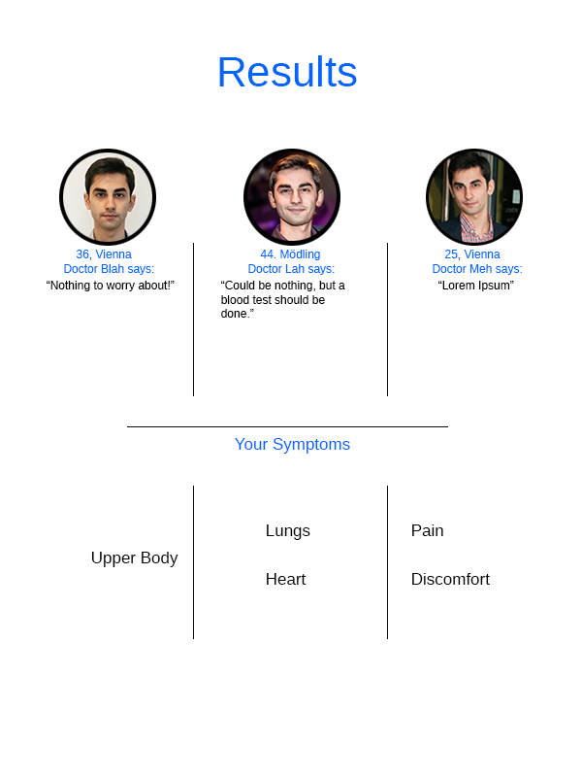

Clicking onto the profile picture of a doctor will show a pop-up containing more information.

